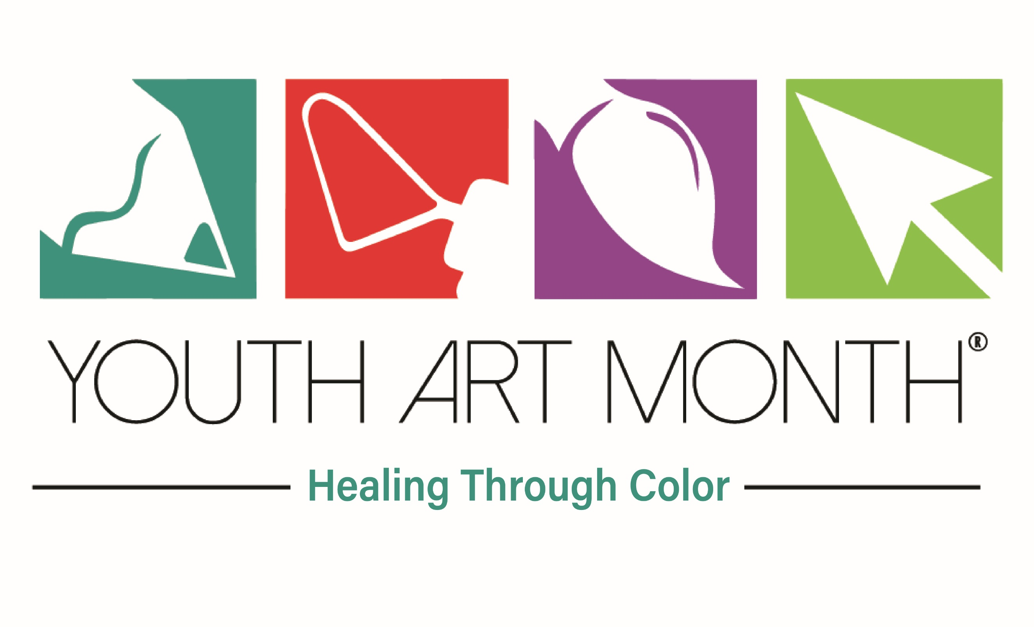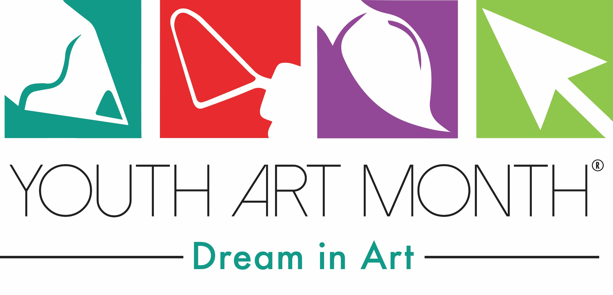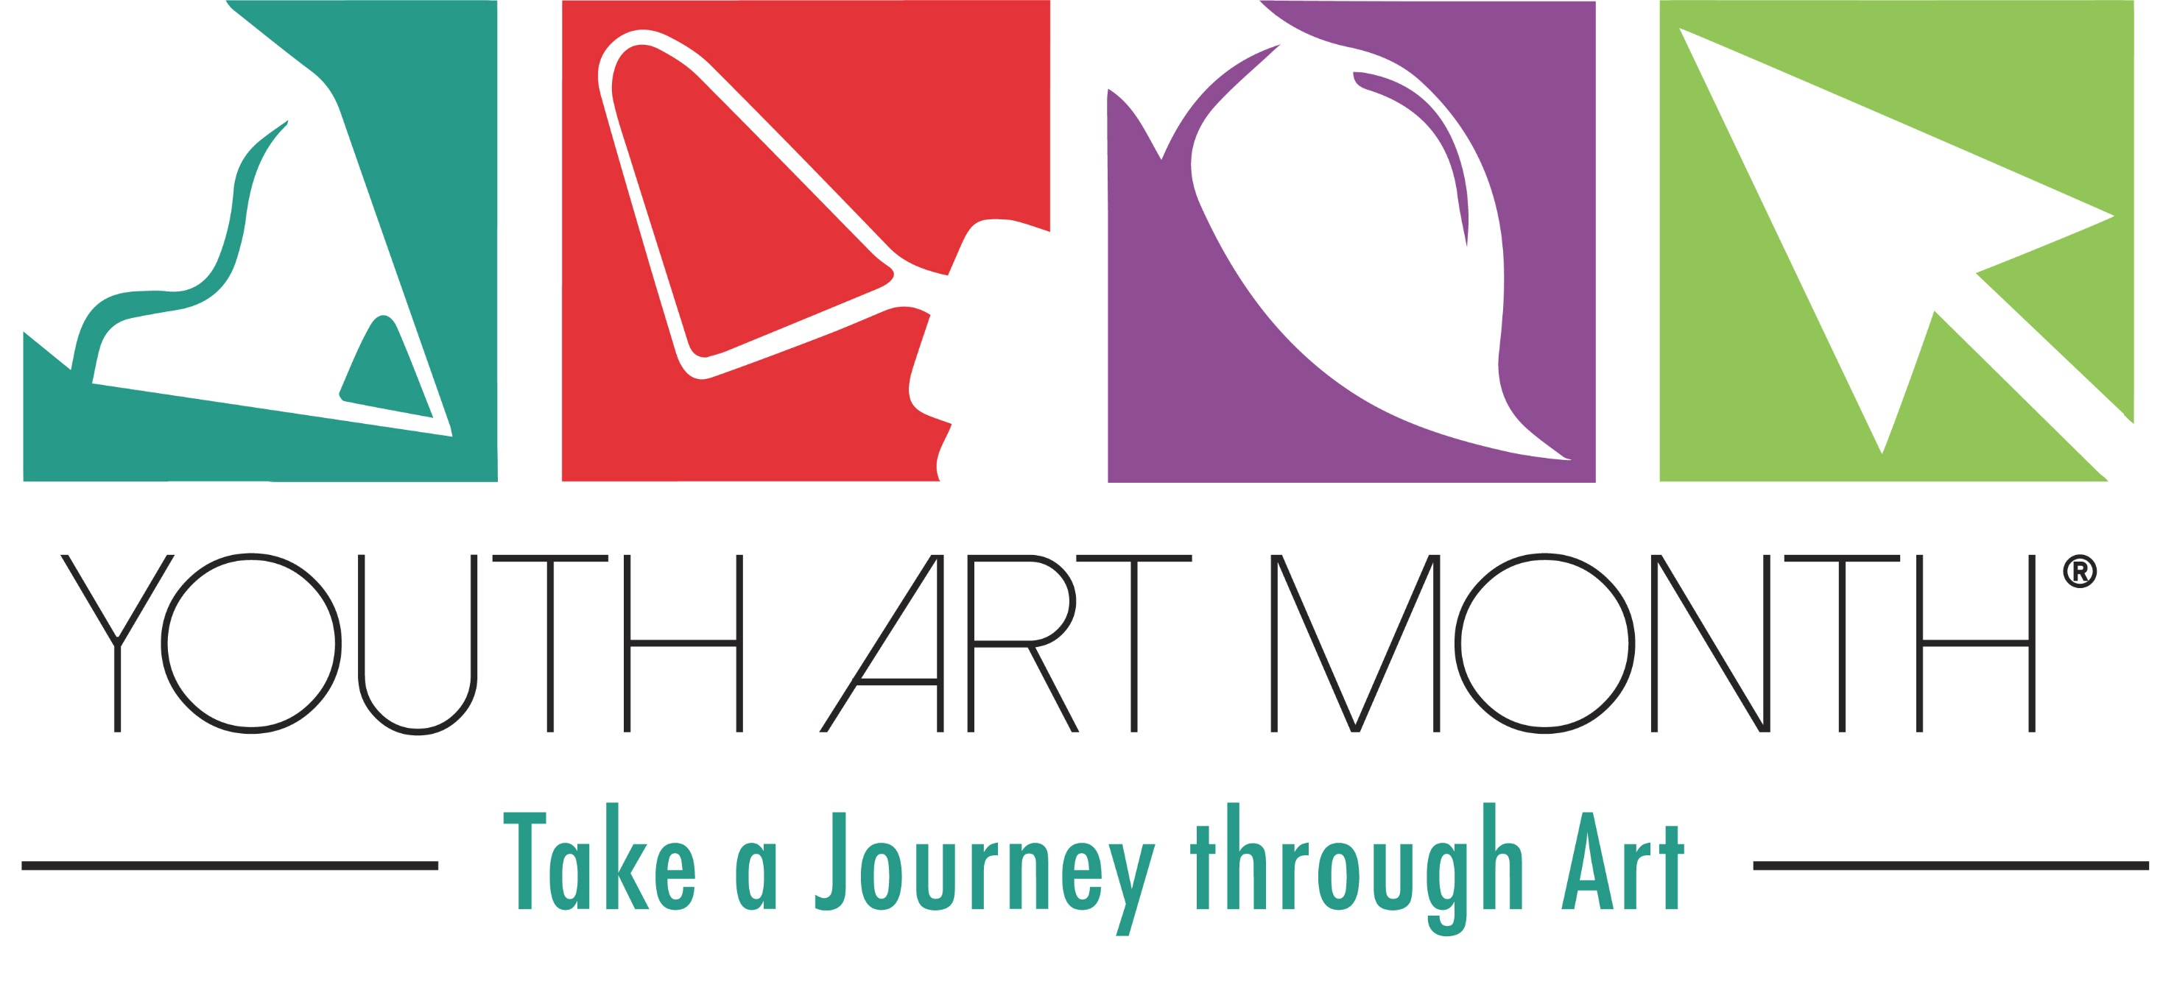

DATE
ADDRESS
PHONE/FAX
EMAIL

Dear
It’s almost time to celebrate Youth Art Month!
- Youth Art Month encourages commitment to the arts by students, community organizations, Youth Art Month brings attention to K-12 visual art education and encourages support for quality school art programs.
- Youth Art Month provides a forum for acknowledging skills that are fostered through experiences in the visual arts that are not possible in other subjects in the curriculum.
Numerous studies published over the last decade by both researchers and educators bring focus to the many skills that children learn over the course of their K-12 education as a result of their participation in the visual arts. Confidence, focus, dedication and accountability are just a few.
One of the most important skills children learn from visual art education is creativity.
“One of the hallmarks of quality visual arts education is its focus on creativity. Students in art classrooms at all instructional levels are routinely called upon to use their creativity to solve problems and to express their ideas. Art teachers are steeped in the knowledge and skills that foster creativity and they use the visual arts curriculum to enable their students to explore their own creative powers. Nurturing and developing students’ creative capacities are vitally important for advancement in the workforce and for maintaining American’s leadership role in the world.” **
A variety of activities take place across the country at the local and state level in support of Youth Art Month, including a student flag design program. The winning design for the state is made into a flag, and the flag is displayed in the Youth Art Month Museum at the National Art Education Association Conference in March. Art exhibits showcasing the outstanding work from students of all ages take place all across the state.
Please join us in our efforts to spotlight art education by issuing a Proclamation recognizing Youth Art Month.
Thank you for your time and consideration and I look forward to hearing from your office in the near future.

Sincerely,
Name
Address
Email
Phone

